Institute for the Advancement
Of Hawaiian Affairs
86-641 Pu`uhulu Road
Wai`anae, HI 96692

August 27, 2020
Desk of Pōkā Laenui
Executive Director
plaenui@hawaiianperspectives.org

to: EV21 Project Mgr. Army West Loch EA
Naval Facilities Engineering Command, Pacific
258 Makalapa, Drive Suite 100
Joint Base Pearl Harbor-Hickam, HI 96860-3134

Copies to: OHA
Relevant Neighborhood Boards
Relevant Legislators
Relevant City Council members
Congressional representatives

Aloha recipients of this letter;

PUBLIC TESTIMONY RE: NAVFAC Pacific has prepared an Environmental Assessment (EA) on behalf of Joint Base Pearl Harbor-Hikam (JBPHH0 in accordance with NEPA

JBPHH proposes the U.S. Army’s construction of new magazines and/or repair/modernization of existing magazines to serve as the U.S. Army’s Ammunition Supply Point on the island of Oahu, Hawaii.

I oppose the plan.

I call for a longer response period as the implications of this plan has such a wide impact upon the Hawaii society and I am not convinced that there has been an adequate airing of this matter in the concerned public.

I also believe that an Environmental Assessment is inadequate and that a full Environmental Impact Statement is appropriate before any action is taken to advance this plan.

The plan contains too much uncertainty and undisclosed materials such that the public is unable to effectively participate in this process or to condone an action which it does not understand. There has been insufficient public vetting or review by the community or by the City or State legislative reviews. It appears that a full Environmental Impact Statement should be done rather than an Environmental Assessment given the environmental impact this proposed action may have.

The John M. Bond Kanahili hui correspondence on August 24, 2020 has already submitted its objection to the plan and I associate myself with those concerns. I am also associating myself with the blast analysis he uses as well as pictures to show the blast impact on the West O`ahu community.

I am further concerned about the impact by the weather in the event of an accident, either by a blast or by leakage or other release of the materials to be stored, or in the process of transport, both to and away from the location identified. Even without an event called an accident, the weather can have a continuous and gradual impact upon the storage facility and I do not believe that the plan has given adequate consideration to the changing weather patterns and its effect upon the storage facility planned.

Furthermore, there needs to be a full disclosure of the types of armaments to be moved and stored. Are there atomic, biological, or chemical weapons included in this anticipated storage bunkers? What are the amounts, ages, containment methods, transporting specifications and what are the plans for reduction and over what period? Are there any virus or virus remnants which are being stockpiled?

As to the answers to all of the above, who are the officials, agents or employees of the DoD making the certification of the truth of their responses, and will such statements be made under oath and subject to penalties for perjury? In other words, how are we able to verify the truth of the statements made by the DoD given the politicization and lies we have received from those in power, especially during the present administration? Will there be an opportunity for verification by a civilian body unassociated with the DoD to the representations made by the DoD/military?

The Environmental Assessment evaluates the potential environmental impacts associated with two action alternatives (including the Preferred Alternative), and the No‐Action Alternative for the following environmental components: cultural resources, terrestrial biological resources, land use, public health and safety, socioeconomics, and environmental justice. Because potential impacts were considered to be negligible or nonexistent, the following resource areas were not analyzed in detail in this EA: airspace, air quality, geological resources, hazardous wastes and materials, infrastructure, marine biological resources, noise, transportation, visual resources, and water resources. I disagree with the conclusion of what is to be considered negligible or nonexistent.

In the event of a major or minor disaster such as an explosion of the storage facilities, it seems airspace will certainly be implicated. If we assume a blast arc wave of 3.6 miles on land from a point of origin, is it safe to assume the same arc or greater into the airspace? What is the potential impact upon commercial, civilian and military flights overhead within this arc? Is this not a heavy traveled air space located close to or in the path of flights in and out of Hickam landing field or the Dan Inouye International Airport? Will there be an airspace above the storage site which will be marked off as a no-fly zone for both civilian and military flights? How will such a no-fly zone affect our commercial industries such as tourism and business travel for international conventions? Has there been a financial analysis of the impact as a result of any change in flight patterns or times for travel?

Why was air quality not considered? In the event of a major or minor disaster such as an explosion of the storage facility or leakage to any of the biological or chemical weapons, or hurricane or other large storm damage, why is there no analysis to the quality of the air and the possible impact upon the fauna and flora of an extended area where the winds are likely to carry the leakage or explosive remnants? Are any of the colored (blue, red, orange, etc.) agents used previously in the war in Viet Nam and in other wars subsequently anticipated to be stored in this facility?

Why were geological resources not considered? What is the soil, coral, or volcanic make-up of the ground upon and within which the storage facility is to be located? What is the water table like in this area? How does the underground streams run? What would be the impact of a major or minor explosive force upon the underground geology directly below and within a blast area of the facility? How much further would a blast wave travel underground from above ground?

Are there any hazardous wastes stored or being transported within the blast area’s 3.6 miles range and how would a blast affect the storage or transportation of such hazardous wastes? Why was hazardous waste not taken into consideration for this EA? What is the route of hazardous waste materials being taken to the storage facility? What form of transportation are being used? Will the public be alerted to the fact that hazardous waste would be passing through its community? If so, how long in advance and by what means of notice? If old armaments are found in the Asia or Pacific Region such as chemical weapons or other hazardous waste, would this site serve as a disposal or deposit site? What assurance do we have regarding this matter?

Why were marine biological resources not considered in this EA? What are the marine biological resources in this area, including the possibility of Hawaiian o`opu and other animal and plant life residing in underground fresh or brackish water reservoirs or streams? What would be the impact upon those marine biological resources? Who has the DoD contacted to make this inquiry? Has the native Hawaiian community been specifically notified to consider the impact of their interest in subsurface materials and the possible cultural and food implications? If so, who, when and with what result?

What are the surface and below surface natural water resources in this vicinity and within the 3.6 mile blast wave arc in the event of a blast at the facility? What would be the impact of such a blast for the immediate as well as long term water use? How would it affect the fresh/brackish water flow into the ocean? What Hawaiian specialists were contacted and consulted on this matter? Was the Office of Hawaiian Affairs and the Hawaiian Homes Commission administration consulted, and with what response?

The EA does not discuss the acceptable damage to the civilian environment of O`ahu and the Hawaiian Island chain in the event of a nuclear explosion by one of the stored weapons at West Loch. What would be the chain reaction of other nuclear explosions and the associated release of nerve agents and other biological weapons? What would be the blast area of the initial and of the secondary blast in the event of an explosion at ground surface at the new storage facility? What would be the blast areas in the event of two or more blasts occurring simultaneously? What concurrent safety measures will be taken by DoD to protect the civilian population to be impacted by such a blast area as this storage facility is being constructed?

What of the chemical weapons release in the event of a chain reaction of release?

Such accidents could be done by many possible events, not necessarily man made. It could be by fire, wind, water, and any other climatic impact on the environment. It could be by failure of the human personnel, by lack of manning because of a medical pandemic, or any number of unforeseen possibilities, including intentional acts. When the potential for such great disasters as a chain of nuclear explosions is posed, the minimal possibilities must be considered and prepared for or the plan for storage abandoned. Was this considered and what are the probabilities work-up and the steps to be taken to obviate such possibilities?

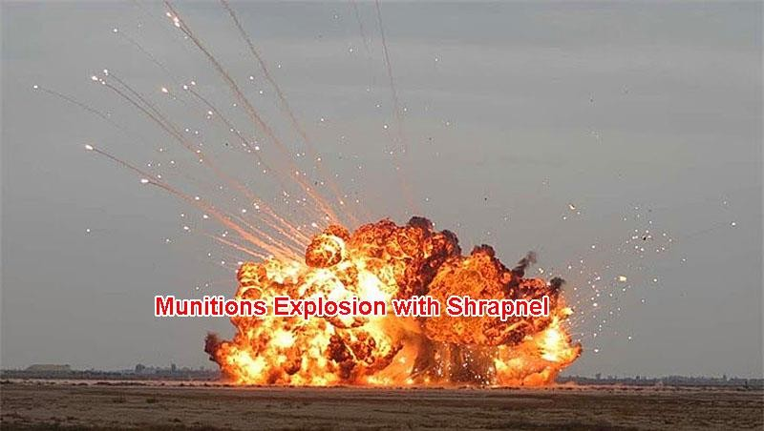

Shrapnel can travel very long distances from the initial explosion and is hot, razor-like shards of metal.

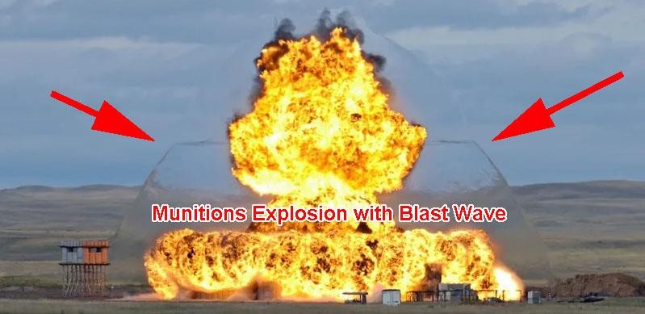

The overpressure blast wave can travel for miles carrying glass, wood debris, concrete over a wide area.

What are the DoD’s plans for a continuously expanding facility at West Loch? Please make all internal communications which reveal future possibilities for an expanded increase in storage for more powerful explosives and missiles, and explain what safety measures are now being taken in the event of such a mission creep once the munition storage is established as proposed in this EA? This is a question which should be considered and evaluated at this point by the very nature of the creeping expansion of the facility once established and each increased use of the facility becomes nothing more than a minimalized expansions as part of an avoidance of this environmental review process.

In view of the U.S. policy of neither confirming or denying storage or possession of nuclear weapons, we must accept that there are likely stored at West Loch such as cruise missiles. Therefore, the public, in reviewing the storage of weapons at West Loch must approach the facility as containing nuclear weapons. Unless and until the storage of nuclear weapons are denied and its denial subject to reasonable civilian verification by independent observers, we must proceed with the assumption of nuclear weapons being stored.

Just as much as nuclear weapons follow a non-disclosure policy of the United States, similarly, is the expectation of the possession and storage of biological and chemical weapons. Unless we have an affidavit by a high official with the DoD who has personal knowledge of the types of armaments to be stored at this facility, which affidavit would be subject to civilian verification, this analysis of the EA must be done with the expectation that there are such weaponry to be stored at this facility. In the event such affidavit, be shown to be untrue in the future, the facility should immediately be shut down and all stored materials removed and or destroyed expeditiously. Federal Regulations regarding storage of Chemical or Biological weapons should not serve as a substitute for a response by a person in the know and in charge of such storage, as we are all very aware of how easy it is for an administration to simply pass an executive order changing the course of Chemical or Biological weapons storage and this danger goes unnoticed for a period of time.

As such, I strenuously object to the use of West Loch for the storage contemplated by the EA.
MOTSU stands for Military Ocean Terminal Sunny Point in North Carolina, operated by the Army 596th Transportation Brigade. It has been revealed in 2018 that, in a possible munitions blast radius affecting West Oahu finding the Vulnerable Building Distance (VBD) extends out to 5833m (3.6 miles) affecting Kapolei, Ewa communities, Kunia-Waipahu, Ford Island-Hickam, Haseko, and Ewa Beach-Iroquois Point. The blast effect could include a blast wave, shrapnel and in the yellow and green circles could cause large casualties, deaths and flattened buildings. (see photos below)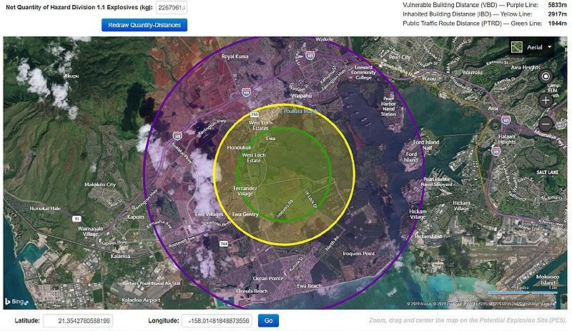
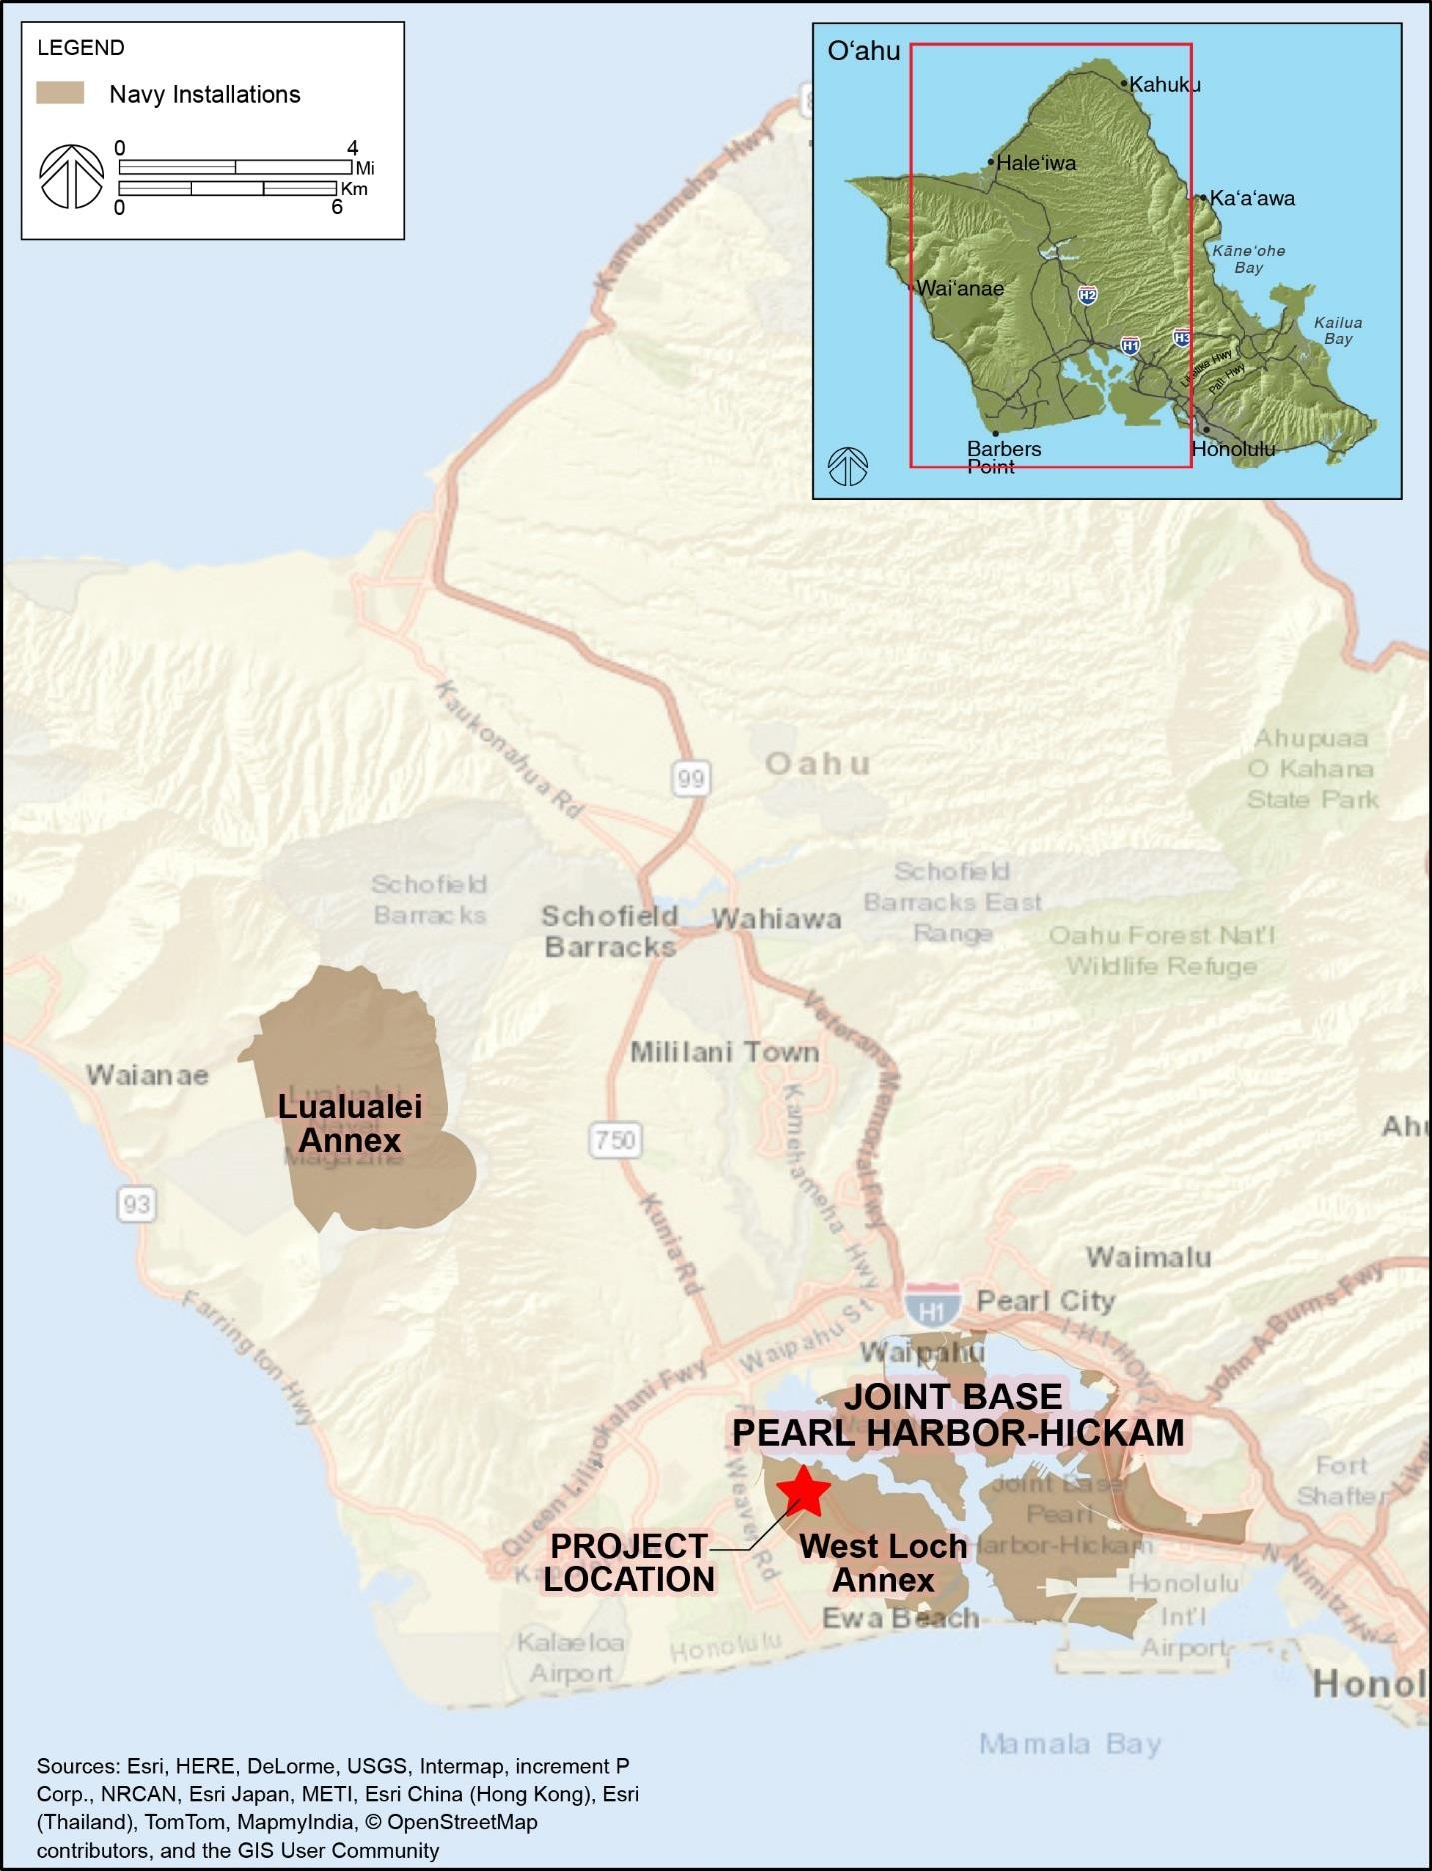

There are numerous historic examples of munitions explosions that include the huge 1917 Halifax, Nova Scotia disaster which killed 2000 and injured 9000 people. Shrapnel can travel very long distances from the initial explosion and is hot, razor-like shards of metal. That MOTSU report and community meetings clearly show that the planned West Loch Army Munitions Complex would present a clear and dangerous community disaster threat and the required protective Environmental Quality Standards Directive (EQSD), etc., is not possible in the location proposed. The NAVFAC Army EA clearly evades this fact.

With all of these munitions, missiles, etc, coming in to be stored and transported to forward Pacific areas the Army and NAVFAC needs to be honest and tell all of the affected communities, which include not only the Ewa- West Oahu community but all of the island of O`ahu, considering the assumption of storage of nuclear weapons, that they will be creating a major Pacific munitions storage and shipping port like MOTSU and that the same EQSD rules and regulations apply. Storing huge amounts of ordinance near a major population has serious consequences that should not and cannot just be swept under the rug and hidden from them. Let us take a lesson from the recent explosion in Beirut containing merely fertilizer!

West Loch is going to become a major Indo-Pacific military munitions terminal, modeled after MOTSU in North Carolina. These large Navy supply and munitions ships are part of the Pacific war logistics strategy that will allow Army and Marine Corps combat deployments with advanced weapons and munitions to forward bases of operation. Here is the clue: The Navy performed construction dredging and widening of portions of the West Loch Channel. The purpose is to provide berthing facilities for the Advanced Auxiliary Dry Cargo Ships (TAKE). The previous depth and width of West Loch Channel had been inadequate for T-AKE vessels to navigate to Wharves 1-3. The T-AKE is a relatively new Combat Logistics Force Underway Replenishment Naval vessel which is larger than previous ships used to transport ordnance and ammunition. Thus, portions of West Loch Channel were dredged and widened to supplement and facilitate ordnance re-supply in support of Navy mission requirements.

This is an immediate RED FLAG to all parties having unfriendly designs upon U.S. forces and military strength. It becomes a target, just as Pearl Harbor had been by the Japan attack on December 7, 1941. However, this target will contain nuclear, biological, and chemical weapons lying within a civilian community! But can we really expect an enemy of the United States strike such a target at the cost of so many civilian lives, including innocent children and the elderly, those people who have nothing to do with the U.S. forces? Would an enemy snuff out the lives of everyone in the Ewa community in an instant by the explosion of a nuclear weapon? History is the best caution of future action.

What did the United States do over Hiroshima and Nagasaki under a claim to “end the war?” What would an enemy of the U.S. do for a first strike so devastating as to “end the war” before one begins, what the U.S. has called a “pre-emptive strike?’

Basically, West Loch will again take on the same role it had in past Pacific wars supporting a Maritime Prepositioning Force. However, the local Ewa and West Oahu communities are being kept in the dark about the major impacts this force projection will bring in the way of advanced weapons, missiles, etc. All of this are extremely dangerous and no valid EQSD has been disclosed. The DoD is planning on placing a time bomb in the Ewa/West O`ahu community with implications throughout the island of O`ahu!

I suggest an alternate proposal: The DoD should consider the alternative of Peace by peaceful means. Change the people who are designing war plans from the current war-lords and politicians. Let’s hear the voices of the victims of war. Let’s hear the voices of the leaders in the peace movement. Let’s hear the voices of the mothers and fathers whose children have been sent off to wars and have not returned or returned maimed physically and psychologically. Let’s hear of the wounded themselves, both wounded veterans as well as civilians in the various populations, including from those born after the wars but still facing the weapons effects many years later. Let’s hear of the indigenous peoples whose lands are being ravaged with the war implements of the war lords.

Let’s make appropriate use of the East West Center (with CIA influence removed) and the Matsunaga Peace Institute located at the University of Hawaii, putting them to work on the many contacts with Russia, China and Korea to speak of a peace approach and a move to decrease weapons to a point of total elimination of all offensive weapons.

Until then, use the existing remote Lualualei area and improve the Kolekole Pass road. The Army Munitions Complex at West Loch annex does NOT have the EQSD blast zone buffer area to be safe. And for goodness sake, plan on reduction of weapons possession, even to the extent of weapons reduction unilaterally.

Sincerely,

/s/ Pōkō Laenui
Pōkā Laenui, Esq.
Institute for the Advancement of Hawaiian Affairs
86-641 Puuhulu Rd.
Waianae, HI 96792

